**Shubham Garg**

**9919103057**

**F2**

**Lab Assignment**

**Q.1 Write a C++ program to display the skills of a person according to his/her profession using inheritance.**

**#include<iostream>**

**using namespace std;**

**class pro**

**{**

**public:**

**pro()**

**{**

**cout<<"Your Profession:";**

**}**

**};**

**class Artist : public pro**

**{**

**public:**

**Artist():pro()**

**{**

**cout<<"Artist\nSkills : Persistence,Patience,Passion,A sense of adventure and Discipline.";**

**}**

**};**

**class Dancer : public pro**

**{**

**public:**

**Dancer():pro()**

**{**

**cout<<"Dancer\nSkills : Goal-directed actions that are observable as small units of engagement in daily life occupations";**

**}**

**};**

**class Engineer : public pro**

**{**

**public:**

**Engineer():pro()**

**{**

**cout<<"Enginner\nSkills : Critical thinking,communication,project and time management";**

**}**

**};**

**class Doctor : public pro**

**{**

**public:**

**Doctor():pro()**

**{**

**cout<<"Doctor\nSkills : Compassion,Understanding,Empathy,Honesty,Competence,Commitment,Humanity and Courage";**

**}**

**};**

**int main()**

**{**

**cout<<"This code belongs to Shubham_9919103057\n";**

**int ch;**

**cout<<"Choices of the pros:-"<<endl;**

**cout<<"1.Engineer"<<endl;**

**cout<<"2.Doctor"<<endl;**

**cout<<"3.Artist"<<endl;**

**cout<<"4.Dancer"<<endl;**

**cout<<"5.Exit";**

**while(1)**

**{**

**cout<<endl<<endl<<"Enter your choice:";**

**cin>>ch;**

**if(ch==1)**

**Engineer e;**

**else if(ch==2)**

**Doctor d;**

**else if(ch==3)**

**Artist a;**

**else if(ch==4)**

**Dancer d;**

**else if(ch==5)**

**break;**

**}**

**return 0;**

**}**

**Output :**

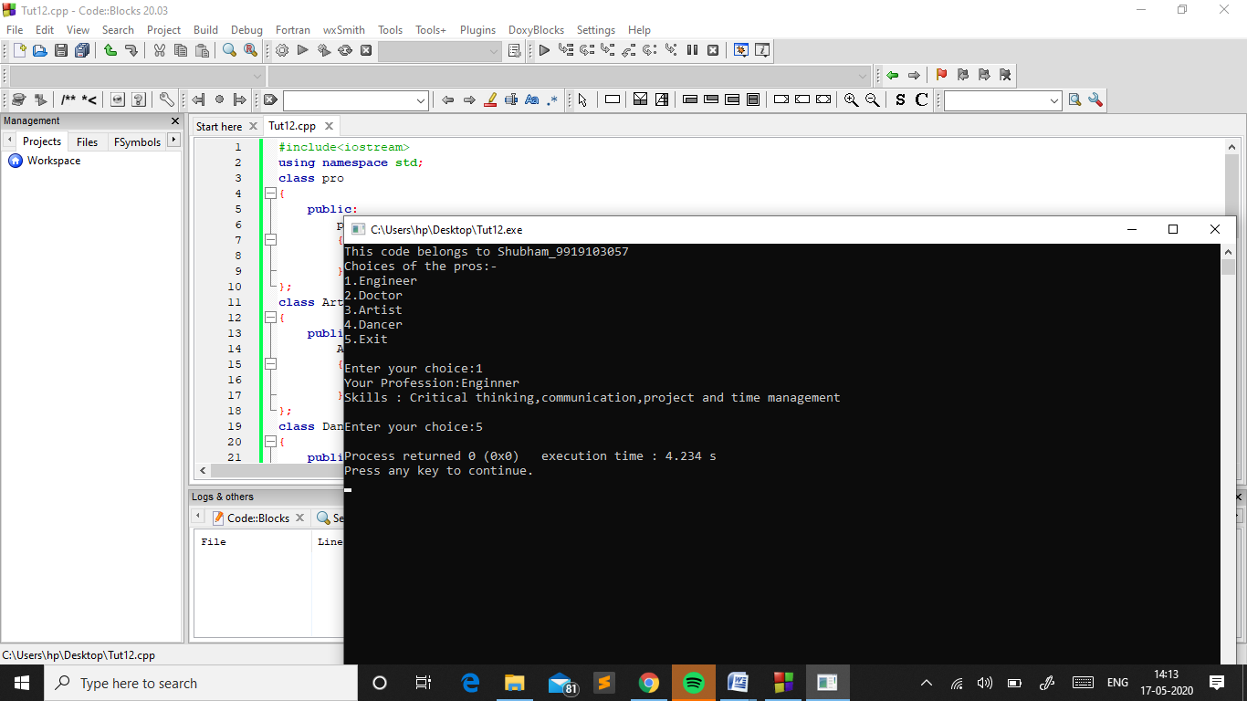

**Q.2 Write a C++ program to read and print employee information using multiple inheritance.**

**#include<iostream>**

**#include<cstdio>**

**using namespace std;**

**class a1**

**{**

**private:**

**string name,address;**

**protected:**

**void get()**

**{**

**cout<<"Enter Name: "<<endl;**

**fflush(stdin);**

**getline(cin,name);**

**cout<<"Enter Address: "<<endl;**

**fflush(stdin);**

**getline(cin,address);**

**}**

**void show()**

**{**

**cout<<"Name :"<<name<<endl;**

**cout<<"Address : "<<address<<endl;**

**}**

**};**

**class a2**

**{**

**private:**

**string occ;**

**int salary;**

**protected:**

**void get()**

**{**

**cout<<"Enter Occupation:"<<endl;**

**fflush(stdin);**

**getline(cin,occ);**

**cout<<"Enter salary: "<<endl;**

**fflush(stdin);**

**cin>>salary;**

**}**

**void show()**

**{**

**cout<<"Occupation :"<<occ<<endl;**

**cout<<"Salary: "<<salary<<endl;**

**}**

**};**

**class b:public a1,public a2**

**{**

**public:**

**b()**

**{**

**a1::get();**

**a2::get();**

**}**

**void showdata()**

**{**

**a1::show();**

**a2::show();**

**}**

**};**

**int main()**

**{**

**cout<<"This code belongs to Shubham_9919103057\n";**

**b emp;**

**emp.showdata();**

**return 0;**

**}**

**Output :**

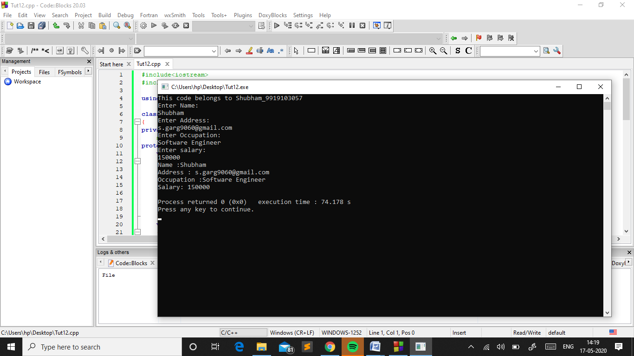

# Q. 3: Write a C++ program to calculate cube, root and square of a number using hierarchical inheritance.

**#include<iostream>**

**#include<math.h>**

**using namespace std;**

**class operation**

**{**

**protected:**

**int n;**

**public:**

**void setdata()**

**{**

**cout<<"\nEnter the value:";**

**cin>>n;**

**}**

**};**

**class cube:public operation**

**{**

**public:**

**void getdata()**

**{**

**cout<<"Cube:"<<pow(n,3)<<endl;**

**}**

**};**

**class root:public operation**

**{**

**public:**

**void getdata()**

**{**

**cout<<"Root:"<<pow(n,0.5)<<endl;**

**}**

**};**

**class square:public operation**

**{**

**public:**

**void getdata()**

**{**

**cout<<"Square:"<<pow(n,2)<<endl;**

**}**

**};**

**int main()**

**{**

**cout<<"This code belongs to Shubham_9919103057\n";**

**int ch;**

**cout<<"Choices:-\n";**

**cout<<"1.Cube\n";**

**cout<<"2.Root\n";**

**cout<<"3.Square\n";**

**cout<<"4.Exit\n";**

**while(1)**

**{**

**cout<<"\nEnter Your choice:";**

**cin>>ch;**

**if(ch==1)**

**{**

**cube c;**

**c.setdata();**

**c.getdata();**

**}**

**else if(ch==2)**

**{**

**root r;**

**r.setdata();**

**r.getdata();**

**}**

**else if(ch==3)**

**{**

**square s;**

**s.setdata();**

**s.getdata();**

**}**

**else if(ch==4) break;**

**}**

**cout<<"Exit!!!";**

**return 0;**

**}**

**Output :**

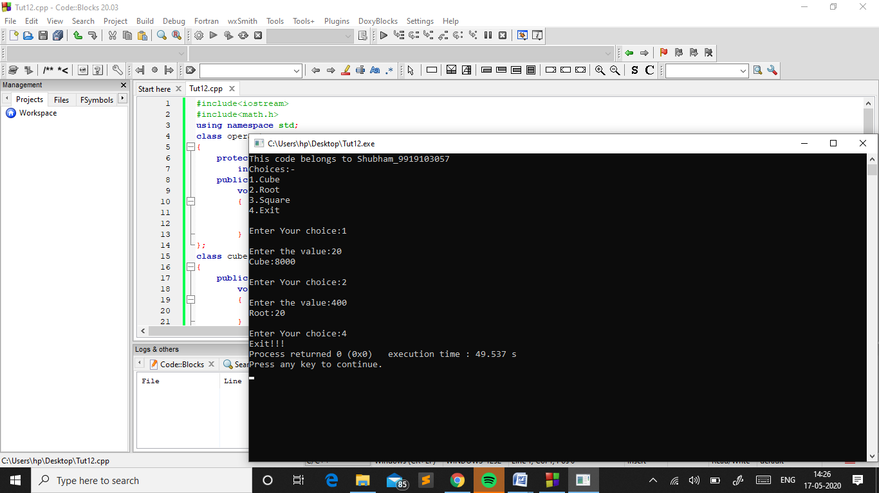

**Q. 4: Create two classes named Mammals and MarineAnimals. Create another class named BlueWhale which inherits both the above classes. Now, create a function in each of these classes which prints "I am mammal", "I am a marine animal" and "I belong to both the categories: Mammals as well as Marine Animals" respectively. Now, create an object for each of the above class and try calling  
1 - function of Mammals by the object of Mammal  
2 - function of MarineAnimal by the object of MarineAnimal  
3 - function of BlueWhale by the object of BlueWhale  
4 - function of each of its parent by the object of BlueWhale**

**#include<iostream>**

**using namespace std;**

**class Mammals**

**{**

**public:**

**void disp1()**

**{**

**cout<<"I am mammal\n";**

**}**

**};**

**class MarineAnimal**

**{**

**public:**

**void disp2()**

**{**

**cout<<"I am a marine animal\n";**

**}**

**};**

**class BlueWhale:public Mammals,public MarineAnimal**

**{**

**public:**

**void disp3()**

**{**

**cout<<"I belong to both the categories: Mammals as well as Marine Animals\n";**

**}**

**};**

**int main()**

**{**

**cout<<"This code belongs to Shubham_9919103057\n";**

**Mammals Mammal;**

**MarineAnimal MarineAnimal;**

**BlueWhale BlueWhale;**

**cout<<"Calling function of Mammals by the object of Mammal:-\n";**

**Mammal.disp1();**

**cout<<"\nCalling function of MarineAnimal by the object of MarineAnimal:-\n";**

**MarineAnimal.disp2();**

**cout<<"\nCalling function of BlueWhale by the object of BlueWhale:-\n";**

**BlueWhale.disp3();**

**cout<<"\nCalling function of each of its parent by the object of BlueWhale:-\n";**

**BlueWhale.disp1();**

**BlueWhale.disp2();**

**return 0;**

**}**

**Output :**

